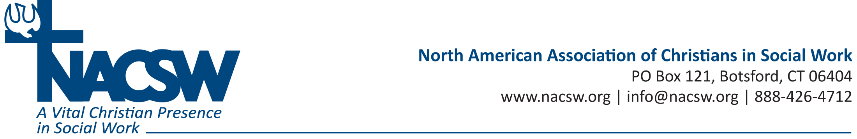

Ann Callahan Biography

Dr. Ann Callahan has a doctorate in social work from the University of Tennessee with a license in clinical social work. She has over 22 years of social work related experience that has cultivated a blend of clinical, administrative, teaching, and research skills. The past ten years, Dr. Callahan has been researching the spiritual dimensions of the therapeutic relationship with an emphasis on hospice and palliative care. This work has resulted in numerous publications and presentations which inform the forthcoming book Spirituality and Hospice Social Work published by Columbia University Press (February, 2017). Dr. Callahan currently works as an associate professor at Eastern Tennessee State University.

