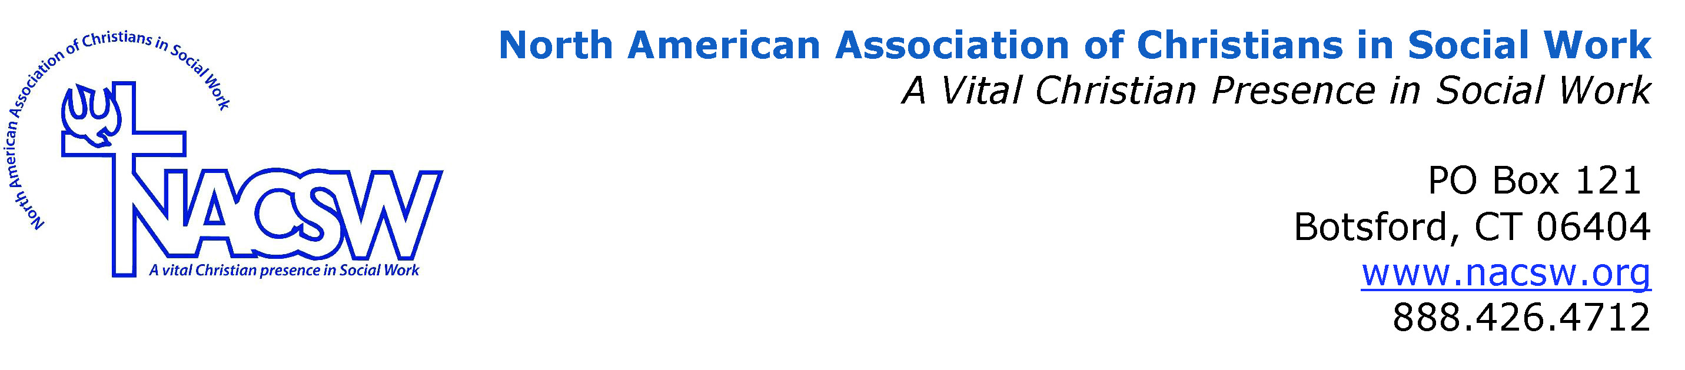

Biography for John Oliver

Reverend Dr. John P. Oliver is the Chief of Chaplain Service and an ACPE certified Clinical Pastoral Education Supervisor at the Durham Veterans Affairs Medical Center in Durham, North Carolina.

He has provided spiritual support to Veterans, their families and loved ones since 1997. John was raised in Colombia, South America. He and his wife Karin have three children. John earned his BA and BM degrees from Samford University, his Masters of Divinity from Southwestern Baptist Theological Seminary, and his Doctor of Ministry degree from Columbia Theological Presbyterian Seminary. John completed his Clinical Pastoral Education Supervisory Training at Duke University Medical Center. John's doctoral work focused on pastoral care to those who have experienced traumatic events. Much of John's energy has been dedicated to training clergy and service professionals to care for people as they engage their spiritual resources. John finds great joy in making music.

