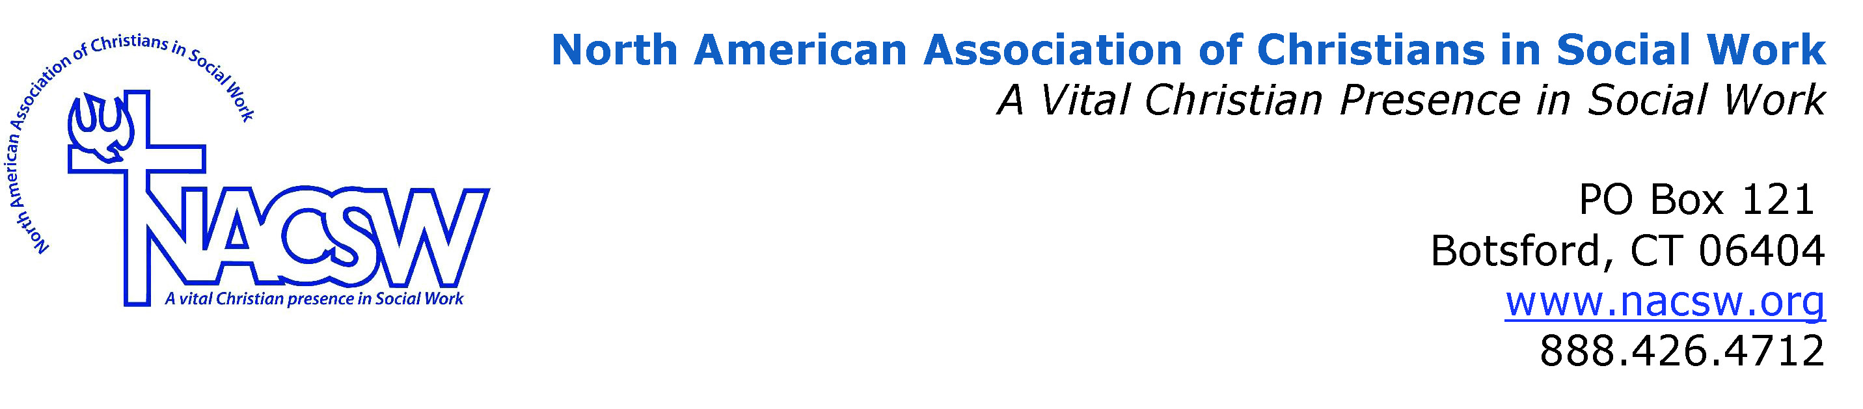
Stacey Barker Biography

Stacey L. Barker, Ph.D., MSW is Professor of Social Work, Program Director, and Department Chair at Eastern Nazarene College in Quincy, MA where she has served for the past 11 years. Dr. Barker’s research interests center around the integration of spirituality, religion, and social work. She is licensed as an Independent Clinical Social Worker in the Commonwealth of Massachusetts and is an active member of NACSW, serving as Associate Editor for Social Work and Christianity and as co-chair of the Boston Chapter.

