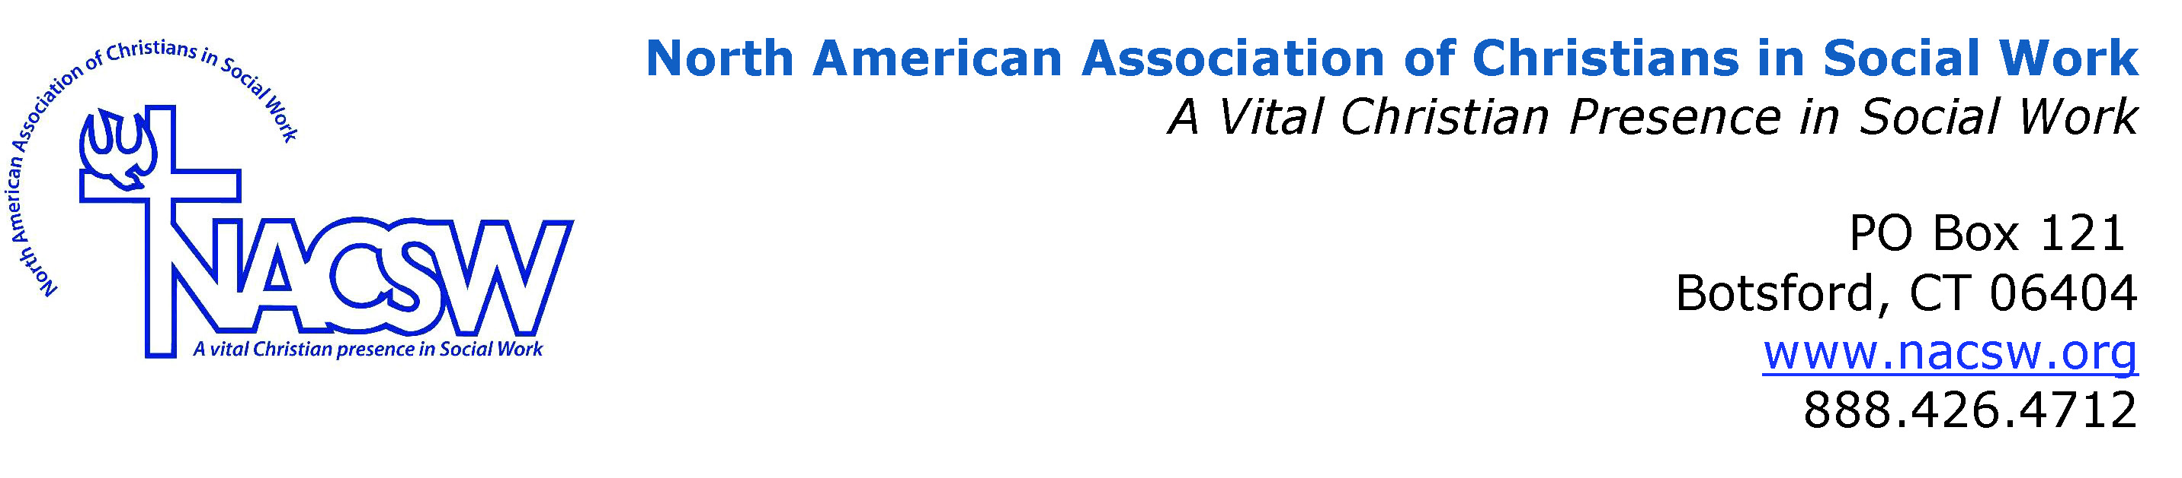
Bio for Jacqueline Dyer

Jacqueline Dyer, Ph.D., LICSW, is Director for In-Ministry Programs at Gordon-Conwell Theological Seminary-Boston, which includes oversight of the MA in Counseling Program. Dr. Dyer is an early career researcher whose interests include domestic violence in faith communities and compassion fatigue in clergy. With more than 20 years in the field post-MSW, Jacqueline continues to provide clinical supervision in the community, and other volunteer work

