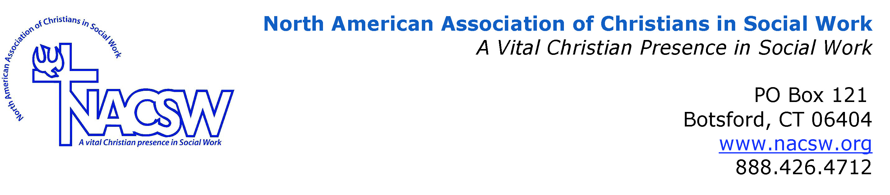
Stephanie Spandl’s Biography

Sister Stephanie Spandl, MSW, LICSW, MAT, a School Sister of Notre Dame, obtained a dual Master’s degree in Social Work and Theology at St. Catherine University/University of St. Thomas. She currently ministers at MORE, a community-based nonprofit, as a clinical social worker specializing in mental health and case management services with immigrants/refugees. She has worked with refugees and immigrants for 20 years in a variety of capacities, including mental health, housing/homelessness and general advocacy.

A primary theological interest is the integration of Catholic/Christian Social Teaching with social work practice. As a graduate student, she assisted in SCU/UST’s efforts to formally integrate Catholic Social Teaching into the social work curriculum and edited the teaching manual created for this endeavor. She has presented on immigration issues at two NACSW conferences and presented on Somali Women’s Mental Health and Working Effectively with Interpreters at Minnesota Social Service Associations conferences. She has served on a local task force addressing refugee mental health, actively participated in the immigration committee of her local province of the School Sisters of Notre Dame, including time as co-chair, and is currently a member of the SCU/UST School of Social Work Advisory Board.

