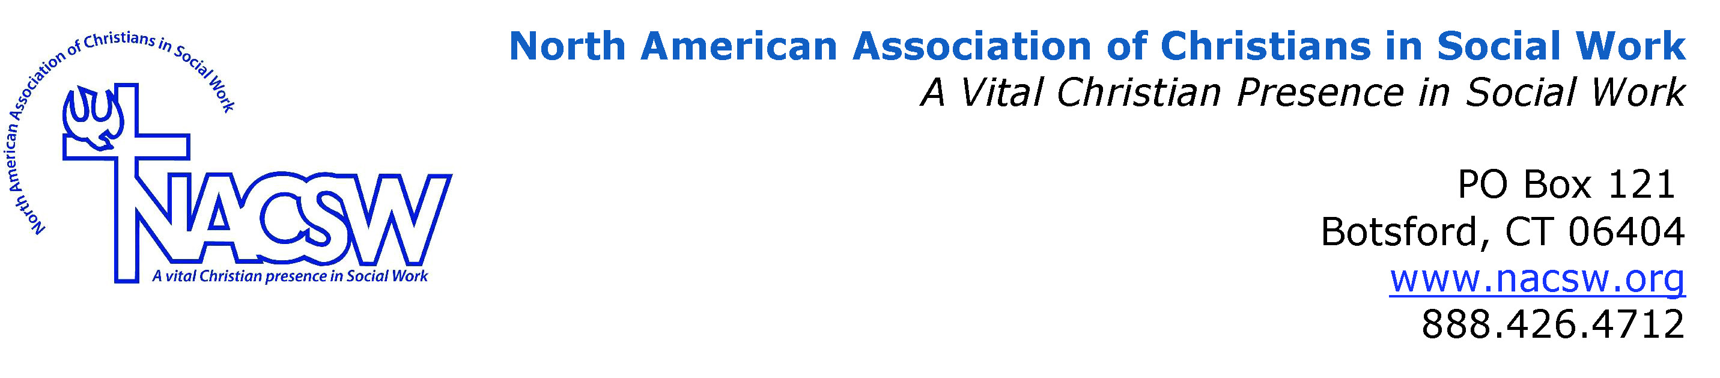

Bio on Janet Knowlton, MSW, LICSW

Janet Knowlton, MSW, LICSW is a graduate of the University of Connecticut, School of Social Work and graduated from Bethel Seminary of the East with a Certificate in Theological Studies in June, 2013. She has worked in the field of social work for over 30 years and is presently employed with the Veterans Administration as a Home Based Primary Care Social Worker at the Worcester VA Outpatient Clinic. Ms. Knowlton is also a woman veteran having served for three years in Frankfurt, Germany in the U.S. Army as a court reporter with the Judge Advocate General (JAG).

