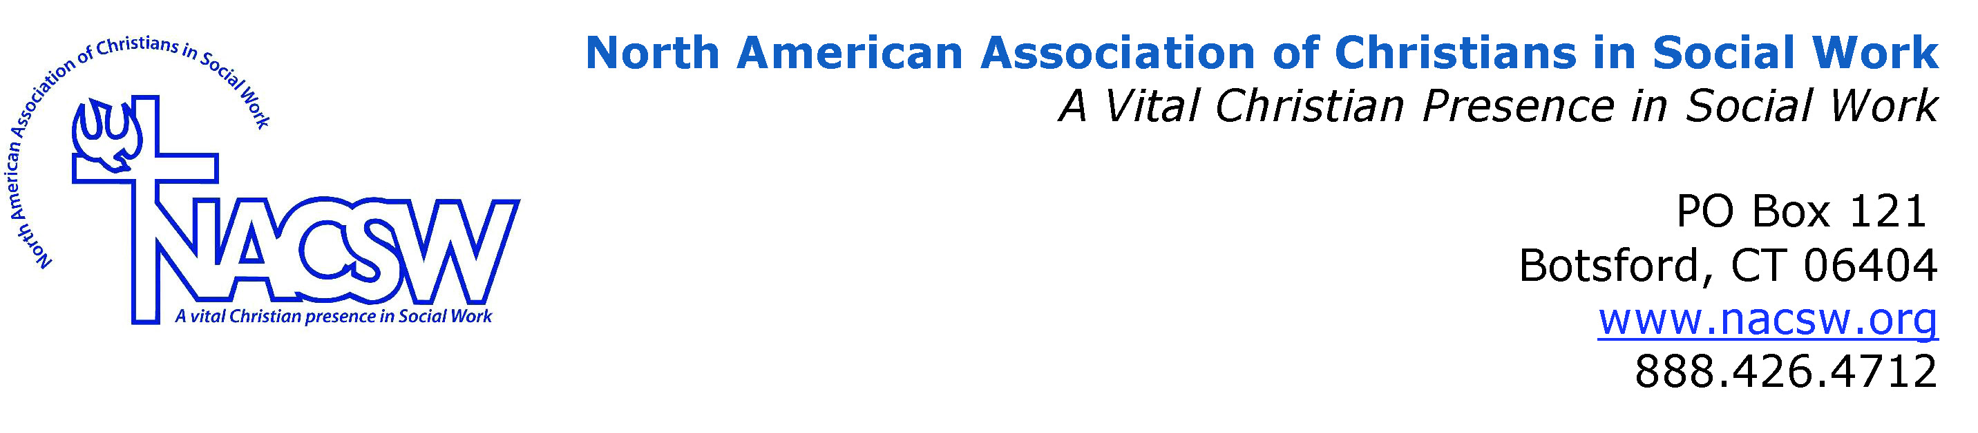<<
Bio for Kesslyn Brade Stennis

Kesslyn Brade Stennis received an MSW from Ohio State University, and an M.Div and Ph.D from Howard University. She also holds a certificate in Women’s Studies, and has worked and researched within the African American faith communities for approximately 15 years. Currently, Kesslyn is an Assistant Professor of Social Work at Bowie State University and part-time Chaplain at Georgetown University where she continues to provide academic and spiritual support for emerging scholars and world leaders.

