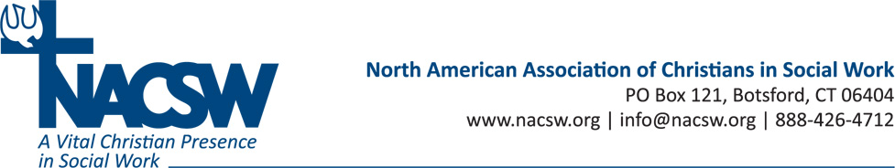

Bio for Steve Corbett, M.Ed
Steve Corbett, M.Ed. is an Assistant Professor of Community Development at Covenant College and serves as a Community Development Specialist for the Chalmers Center. Previously, Steve served as Director of Field Operations and Training for the Chalmers Center. Prior to coming to Covenant College, he worked for Food for the Hungry International (FHI) as the Director of Staff Training, and then later as the Regional Director for Central and South America. Steve has a B.A. from Covenant College and a M.Ed. in Adult Education from the University of Georgia.

