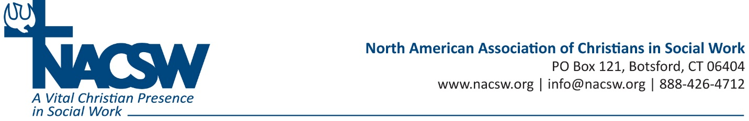

Biography for Bob VandePol

Bob VandePol MSW, LCSW serves as Executive Director of Pine Rest Christian Mental Health Services’ Employee Assistance and Church Assistance programs. Prior to joining the Pine Rest team, he was President of Crisis Care Network, helping to lead it from a startup to the world’s largest provider of Critical Incident Response services to the workplace. Active as a keynote speaker, Mr. VandePol has published and been quoted in business and clinical journals, co-authored book chapters addressing workplace response to tragedy, and has been featured as subject matter expert in numerous video training series. He managed CCN’s Command Center in Manhattan after the 2001 terrorist attacks and frequently consults with businesses, universities, schools, and churches regarding how leaders can accelerate organizational recovery following crises.

Speaking engagements and consultations include international audiences from a variety of professions and industries. Selected engagements include:
- United States Senate – Peer Disaster Committee
- Harvard University World Extreme Medicine Conference
- Zurich Military Contractor Forum
- The World Bank
- The United States Coast Guard
- International Crisis & Risk Communication Conference
- American Hospital Association
- Employee Assistance Professional Association World Conference
- Risk Insurance Management Society
- The Conference Board (US)
- The Conference Board of Canada – Council of Emergency Management
- Peru Seguridad de Minera International Conference on Mining Safety
- National Safety Council World Congress
- National Behavioral Consortium
- Construction Financial Management Association
- Great Lakes Homeland Security Conference
- American Insurance Association
- National Association of Church Business Administrators
- Christian Schools International

Special projects and publications have engaged diverse professional groups. Selected involvements include:
- Co-Chaired the National Action Alliance for Suicide Prevention’s Workplace Taskforce
- Served as Board Member for the National Behavioral Consortium
- Authored Position Leaders to Lead: Management Consultation following Workplace Crisis in the Journal of Employee Assistance
- Developed and recorded web resources with United Health Group in response to the Sandy Hook Elementary School shooting.
- Interviewed by New York City’s CBS radio affiliate regarding the Sandy Hook Elementary School shooting and how adults can now support children.
- Contributing author of A Manager’s Guide to Suicide Postvention in the Workplace: 10 Objectives for Dealing with the Aftermath of a Suicide. Distributed by the American Association of Suicidology’s Workplace Postvention Task Force in partnership with the Carson J Spencer Foundation and Crisis Care Network.
- Co-authored (with Calvin Beyer) The Importance of Managing Human Factors during a Workplace Crisis; a whitepaper distributed by Zurich North America. (2011)
- Co-authored (with George Everly Ph.D) When Tragedy Strikes: Crisis Management for Critical Incidents and Post Traumatic Stress Disorder; a whitepaper distributed by Zurich North America.
- Authored Facilitating Individual and Organizational Resiliency After Workplace Tragedy in Good Company.
- Co-authored (with Mark Attridge Ph.D) The Business Case for Critical Incident Response Services in the Journal of Workplace Behavioral Health.
- Cited in The Conference Board of Canada’s briefing Managing the Risks of Workplace Violence and Harassment.
- Co-authored (with Betty Gilmore Psy.D) Healing the Wounds: How to support your employees in the aftermath of a bank robbery in Texas Banking.
- Quoted in the Wall Street Journal regarding the increase in retail crime during the economic downturn.
- Quoted in Business Insurance magazine regarding the role of the EAP in workplace violence prevention.
- Co-authored (with Calvin Beyer) The High Cost of Workplace Tragedies; Leading Employees through Crises in CFMA’s Building Profits.
- Developed and recorded web resources for ValueOptions in response to the Virginia Tech shooting tragedy.
- Led the Crisis Care Network Clinical Team in development of the acclaimed Best Practices in Critical Incident Response for the Workplace web and on-site training.

