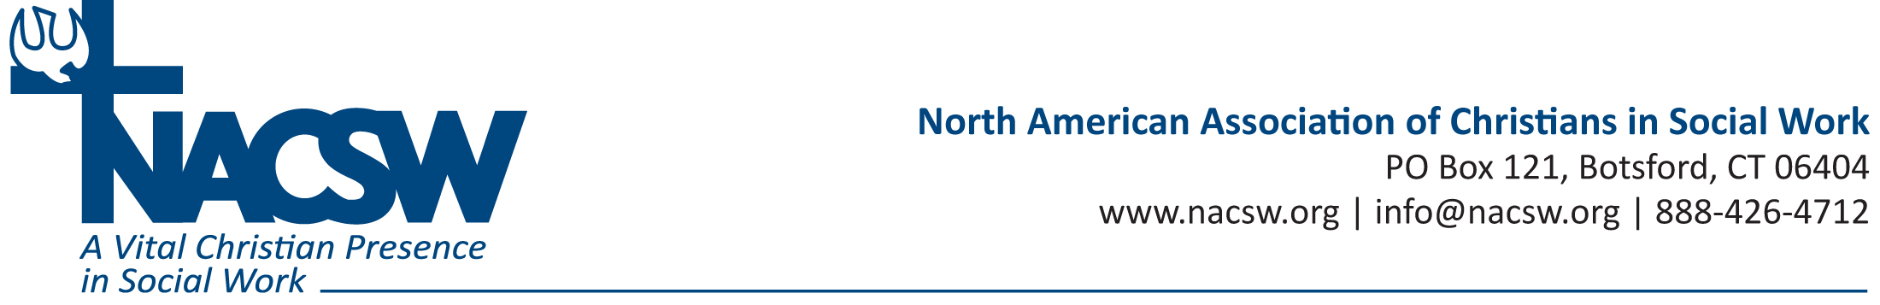

Bio for Elizabeth Wilson, LCSW, PhD

Beth Wilson, LCSW, PHD is a social work professor at Union University. She volunteers with End Slavery TN, co-leads human trafficking prevention groups with high-risk teenage girls. Prior to her academic appointments, her social work experience include clinical work with person with mental illnesses, substance abuse, and senior citizens; community development in low-income communities and various research projects. She graduated from Cairns University with a BS-Bible and BSW; University of Wisconsin with a MSW; and the University of Tennessee, College of Social work with a Ph.D. She currently lives in Humboldt TN with her husband Tom and two children Kaitie and Jacob.

