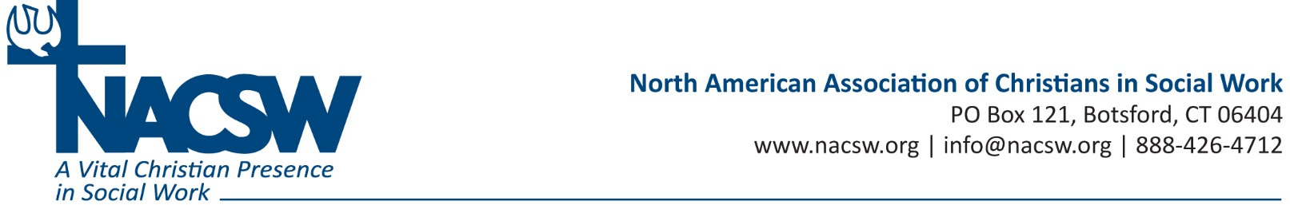

Dr. Rhonda Hudson joined Union University in August, 2006, and currently serves as a Professor of Social Work and BSW Director in the School of Social Work. She teaches in the BSW and MSW programs in Jackson and in Germantown. She is a certified Quality Matters Peer Reviewer for online courses at Union University and at other universities, also.
Dr. Hudson earned her Bachelor’s degree from Florida A & M University, in Tallahassee, FL, and her MSW and PhD degrees from Barry University, in Miami Shores, FL. She is a Licensed Clinical Social Worker (LCSW). Currently, she serves as a board member for Area Relief Ministries, Inc. She serves as the Coordinator for Room in the Inn Homeless Ministry and on the Praise Team at Northside Assembly of God. She is a member of the CSWE Commission on Racial and Ethnic Diversity and also serves on various commissions and task teams in Jackson, TN.

