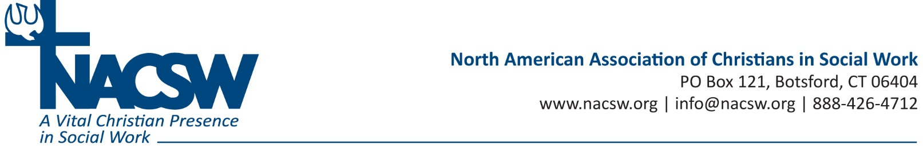

Audio Conference Webinar Biographies

Elizabeth Patterson Roe, PhD, LISW-S teaches social work at Malone University. She and her husband recently moved into the Summit Lake neighborhood of Akron, Ohio to be involved in Christian Community Development with South Street Ministries. Prior to teaching she was involved in community development work in Romania.

Erin Woodson, MSW is the development director of South Street Ministries in Akron, Ohio. South Street is an active and broad Christian Community Development Association organization in scope and services. She lives in the Summit Lake neighborhood of Akron, Ohio in a Christian communal home. Erin uses CCD principles in her individual ministerial activities: the Closely Knit Summit Lake circle, youth discipleship, and civic engagement.

