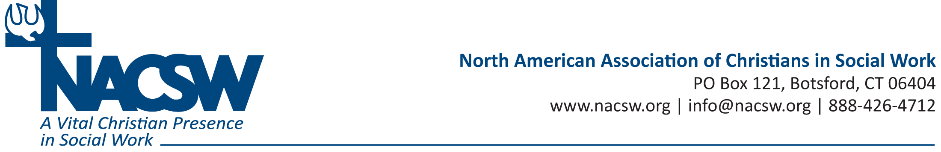

Bio for Denise Anderson, PhD, MSW, LSW
Denise Anderson, PhD, MSW, LSW, joined Olivet Nazarene University’s full-time faculty in 2016 and has 13 years of previous teaching experience in the field of social work. Her areas of specialty within social work are international social work, clinical/mental health, program evaluation and teaching. She is a Licensed Social Worker in the state of Pennsylvania.

In addition, Dr. Anderson’s professional experience includes five years in clinical mental health, 10 years serving as a missionary in the area of compassionate ministries, and online program development and coordination of a bachelor's degree program in theology.

Dr. Anderson is an ordained Elder in the Church of the Nazarene. She is also a member of the North American Association of Christian Social Workers and African Nazarene Women Clergy. One of her greatest joys in life is recruiting social work students, and she has done this for many programs worldwide.

One of her favorite Bible verses is Ephesians 4:29, "Do not let any unwholesome talk come out of your mouths, but only what is helpful for building others up according to their needs, that it may benefit those who listen."

