
Bios for Hugh Drouin, PhD. C.S.W. & Marv Franz, MBA

Dr. Hugh A. Drouin

Commissioner – Social Services Department

The Regional Municipality of Durham

Dr. Drouin is the Commissioner of the Social Services Department in The Regional Municipality of Durham.

Dr. Drouin has a varied and rich background having served as a clinician, college and university professor, administrator, consultant, and seminar leader. He has conducted extensive research in the area of nurturing workplaces and their impact on the stress and morale of employees.

Dr. Drouin holds a Master's Degree in Social Work from the University of Windsor, and a Ph.D. in Social Work Administration from Laval University in Quebec City. He has also attended post graduate clinical studies at Adelphi University in New York City.

He has conducted numerous seminars and workshops for such diverse organizations as General Electric, Canada Post, Royal Bank, Ministry of Health, school boards, District Health Councils, churches, hospitals, social agencies and a variety of professional groups such as teachers, nurses, social workers, occupational therapists, physiotherapists, and a variety of administrators.

He has been on part-time faculty at the School of Social Work McMaster University. He received the McMaster teaching award for his exceptional contributions to teaching in the School of Social Work. He is the author of the booklet Servant Leadership - A Pathway to Care, Excellence and Leadership (2009 and his most recently published book “The Inspired Workplace: How Building Community at Work Unlocks Organizational Potential”.

Dr. Drouin’s vision for his life is “People are Precious”. His life mission is to be an instrument of transformation in the lives of individuals and organizations.

Biography for Marv Franz

Marv Franz is the Principal of New Vantage and consults with leaders, senior management teams, boards and networks of organizations navigating through change processes. He is skilled in helping leaders clarify the challenges they face, facilitating strategy and problem solving processes, and enabling leaders and teams to bring about the change required for their organizations.

To serve his clients, Marv draws upon a unique combination of educational and past work experience. He holds an MBA from the School of Business and Economics at Wilfrid Laurier University specializing in Strategy, and holds university undergraduate degrees in Biology (B.Sc. hons) and Education (B.Ed.) as well as two graduate theology degrees.

Prior to this, from 1994 to 2007, Marv spent twelve years as a team and leadership developer in both Canadian university and international NGO contexts. Over this period he has worked as a manager within university student services departments at Brock University in St. Catharines, Ontario, University of British Columbia in Vancouver, BC, and Wilfrid Laurier University in Waterloo, Ontario. Here he developed and managed staff teams, offered leadership on university management teams, as well as created leadership curriculum, training programs and international service-learning teams in partnership with NGO’s in developing world contexts in Latin America and Africa.

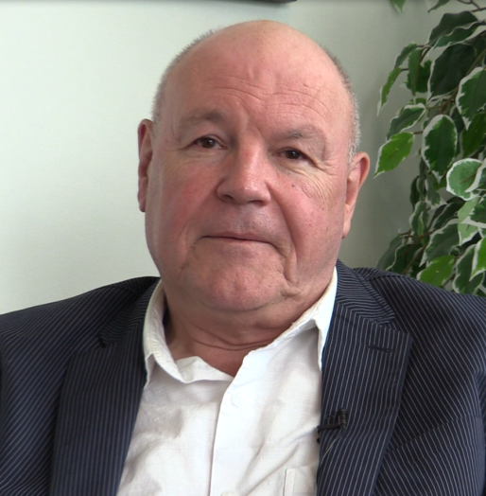
Dr. Hugh Drouin Marv Franz

